Mackinac Straits Health System

Saint Ignace, Michigan

Community Health Needs Assessment

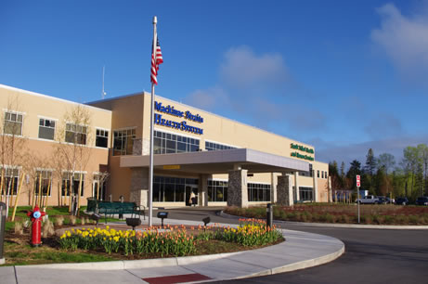

2019

Table of Contents

Introduction 1

Methods 2

CHNA Advisory Committee 2

Community Served Determination 2

CHNA Process 2

Primary Data Collection 3

Secondary Data Collection 3

Information Gaps 4

Community/Demographic Profile – Primary Data Results 4

Population 4

Population by Age 4

Population by Race and Ethnicity 5

Income 6

Secondary Data Results 7

Birth Statistics 7

Insurance 8

General Population Health 9

Screening 10

Leading Causes of Hospitalizations 12

Ambulatory Sensitive Conditions 12

Summary of Key Findings and Prioritized Needs 14

Existing Health Care and other Facilities and Resources 14

Implementation Plan 16

References 17

Appendix 1 - List of Interviewees for Community Input

Appendix 2 - Interview Questions

Appendix 3 - Criteria Used to Prioritize Health Needs

Appendix 4 - Resource List

Appendix 5 - Community Health Needs Assessment Implementation Plan

# **Introduction**

Mackinac Straits Health System, Inc. (MSHS), located in St. Ignace, Michigan, is a nonprofit, nonstock corporation that operates a 15-bed acute care facility, a 48-bed long-term care unit, and several physician clinics in Mackinac County, Michigan. The System provides comprehensive inpatient, outpatient, emergency, and physician clinic services to the residents primarily of Mackinac County and the surrounding areas. MSHS has undertaken a community health needs assessment; a process driven by recent passage of the Patient Protection and Affordable Care Act, which requires tax-exempt hospitals to conduct needs assessments every three years. The purpose of the community health needs assessment is to uncover unmet health needs that exist within the community MSHS serves. Through the assessment, input is gathered from the community and applicable needs are prioritized, with an implementation strategy created to address the prioritized needs.

# **Summary of 2016 Community Health Needs Assessment (CHNA) Activities**

During its 2016 CHNA, MSHS identified seven priorities. Of the seven priorities, MSHS developed plans to manage four priorities. MSHS chose four priorities as a business decision due to the availability of organizational resources. Follow-up from MSHS’ implementation strategies for each of the four priorities is as follows:

Priority One: Mental Health and Substance Abuse

The implementation objectives aimed to enhance collaboration with local and regional agencies on mental health and substance abuse, and enrich community awareness and participation with their programs.

Regarding mental health services, Mackinac Straits Health System began working with a new facility in Mackinac County that serves individuals with behavioral, mental, and medical health needs. This partnership is continually developing, and the facility assists MSHS with placing patients requiring specialized care and services after discharge from an inpatient setting. Also, the facility’s representatives participate in community task force and community behavioral health meetings, and the representatives have expressed openness to working with MSHS to improve the delivery of mental and behavioral health services in Mackinac County.

MSHS continues to help organize and facilitate Community Task Force and Community Behavioral Health meetings. These meetings bring together stakeholders Mackinac and Chippewa counties to discuss stakeholders’ needs, goals and expectations in managing issues. The meetings also include stakeholders from regional and state organizations focused on improving total population health among rural populations. At the meetings ideas for approaching mental and behavioral health concerns are shared and partnerships are forged.

MSHS facilitated a medical education event led by national expert on addiction medicine. This event helped improve the understanding of substance use disorders among those in attendance. MSHS successfully reached outside Mackinac County and secured participation with providers in the surrounding counties. Together, the group learned more about the limited services available for managing individuals addicted to substances.

Priority Two: Access to Pharmacy

MSHS constructed a retail pharmacy to mitigate the community concern of access to pharmacy services. MSHS’ retail pharmacy is open on weekends, and offers delivery services to Mackinac Island. MSHS continues to develop its retail pharmacy services, including the hours of operation and delivery programs to ensure the community’s pharmacy needs remain met.

Priority Three: Lack of insurance/cost of care/co-pays

The implementation objectives aimed to enhance collaboration with agencies, like Community Health Access Coalition (CHAC), that assist individuals secure health insurance. MSHS realized limitations with this strategy, as not all individuals can afford insurance. MSHS continued its Charity Care Program and updated the enrollment criteria for the program. The MSHS social worker acts as a navigator to assist patients who desire enrollment in Medicaid, but the programs have not met all the community’s needs concerning the cost of care and services. MSHS continues to utilize a referral system to connect uninsured patients with our social worker to assist individuals with education and application support.

Priority Four: Obesity/diabetes

The implementation objectives aimed to create a positive impact on the management of diabetes and obesity in the community. MSHS’ work on these measures continues, year over year. MSHS facilitated a medical nutrition therapy program, to which primary care and assisted living patients can be referred. The service is free of charge and exists entirely for community benefit. The program provides education as well as interpersonal support. The population serviced largely suffers from obesity and diabetes, and the age of the participants ranges from pediatric to geriatric. The program is advertised by providers in our clinics, as well as by postings/advertisements in local businesses. MSHS works closely the Sault Tribe of Chippewa Indians and Pinecrest Assisted Living to bring the program to the community. MSHS has realized increased utilization of services as it develops community education for diabetes and obesity.

# **Methods**

## **CHNA Advisory Committee**

The CHNA Advisory committee was formed by Leadership at MSHS. The team was tasked with completing the objectives outlined by the IRS CHNA requirements. The team consisted of the following members:

* James Shannon, Chief Nursing & Quality Officer
* Jason Anderson, Senior Accountant
* Marielle St. Onge, Registered Dietician
* Sharon MacDonald, Patient Advocate & Risk Manager

## **Community Served Determination**

The service area for MSHS was created with input from the MSHS CHNA Advisory Committee. The definition includes Mackinac County.

## **CHNA Process**

The CHNA process utilized to conduct the assessment has been adopted from several of the leading sources on the subject. These sources include:

* Association for Community Health Improvement
* Rural Health Works
* Flex Monitoring Team

The following outline explains the process for conducting the CHNA. Each process is described in more detail throughout the report.

1. Formation of a CHNA advisory committee
2. Definition of the community served by the hospital facility
   1. Demographics of the community
   2. Existing health care facilities and resources
3. Data collection and Analysis
   1. Primary data
   2. Secondary data
4. Identification and prioritization of community health needs and services to meet community health needs
5. Adoption of goals and implementation strategy to respond to prioritized needs in collaboration with community partners
6. Dissemination of priorities and implementation strategy to the public.

## **Primary Data Collection**

Key informational interviews were conducted with members of the community served by MSHS. These individuals were identified by the Committee based on their qualifications to represent the broad interest of the community served. Generally, the interviewees included persons with special knowledge or expertise in public health and persons who represent the medically underserved and vulnerable populations. Interviewees were contacted and asked to participate in the key informational interviews. A list of the interviewees can be found in Appendix 1. A summary of the key findings from the key informational interviews can be found further on in this document.

## **Secondary Data Collection**

Secondary data was collected from a variety of local, county, and state sources to present a community profile, birth and death characteristics, access to health care, chronic diseases, social issues, and other demographic characteristics. Data was collected and presented at the county level and wherever possible, compared to the State of Michigan and the Nation.

The secondary data collected for this analysis was collected from the following sources:

* ESRI, 2019 (Based on US Census Data)
* County Health Rankings
* Michigan Department of Health
* Michigan Vital Statistics

This report presents a summary that highlights the data findings, presents key priorities identified through the CHNA, and MSHS Board-Approved implementation plan.

## **Information Gaps**

Every attempt was made to collect primary, secondary and health-related data relevant to the community served by MSHS. In certain cases, MSHS’ ability to assess all of the community's health needs was limited by a lack of existing health-related data collected at the county level.

# **Community/Demographic Profile – Primary Data Results**

## **Population**

The population in the MSHS service area is expected to decline over the next five years, by 289 people. Michigan is expected to increase by 1.2% or 125,614. Population is expected to rise nationally by over 4%.

**2018 and 2023 Population**



ESRI Business Information Solutions, 2019

## Population by Age

Population was grouped into major age categories for comparison. In general, the Mackinac County has a significantly older population than Michigan and the Nation. Mackinac County population is expected to continue aging over the next five years. This will likely cause a rise in health care utilization as older populations tend to utilize health care services at a higher rate. Health needs will also continue to shift toward disease categories that tend to present at an older age.

**2018 and 2023 Population Age Distribution**

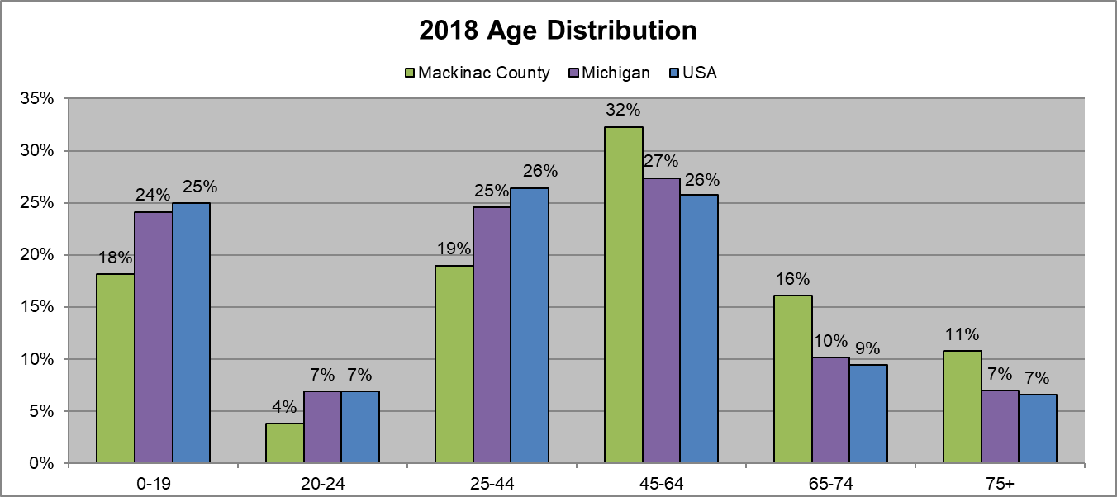

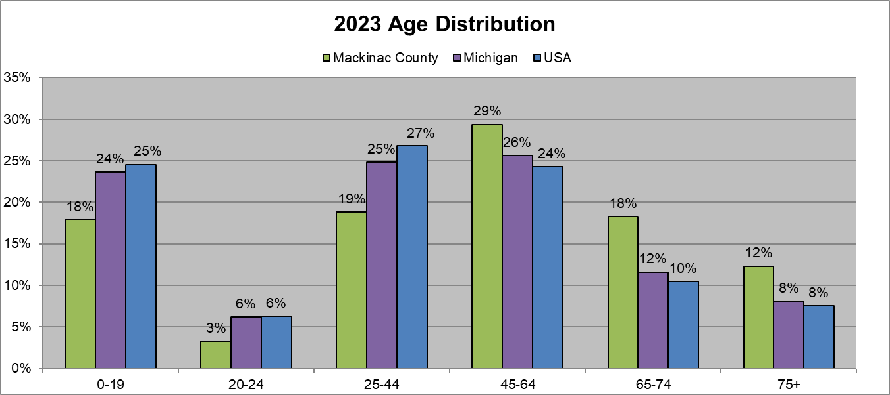

ESRI Business Information Solutions, 2019

## Population by Race and Ethnicity

Mackinac County is predominantly white, equating to roughly 77% of the total population. The American Indian population makes up 17% of the population in Mackinac County, which is significantly higher than the State or Nation as a whole. It is important for MSHS to continue outreach with this subpopulation to ensure that the health needs of all population groups within the County are being met.

**2018 and 2023 Population by Race**



ESRI Business Information Solutions, 2019

## Income

Income data was analyzed for Mackinac County and compared to the state of Michigan and the Nation. 2018 census data reveals that Median and Average household income for Mackinac County is lower than the State and Nation. Over the next five years, income levels are expected to rise in Mackinac County, the State, and the Nation.

**2018 and 2023 Income Levels**



ESRI Business Information Solutions, 2019

# **Secondary Data Results**

## **Birth Statistics**

Rates of low birth rates in a community are often associated with poor health of the mothers. Low birth rates can lead to higher incidences of fetal mortality, inhibited growth and cognitive developments and chronic disease in later life, and is generally a predictor of newborn health and survival. Low birthweight percentages in Mackinac County are in line with Michigan. However, both are higher than the National benchmark.

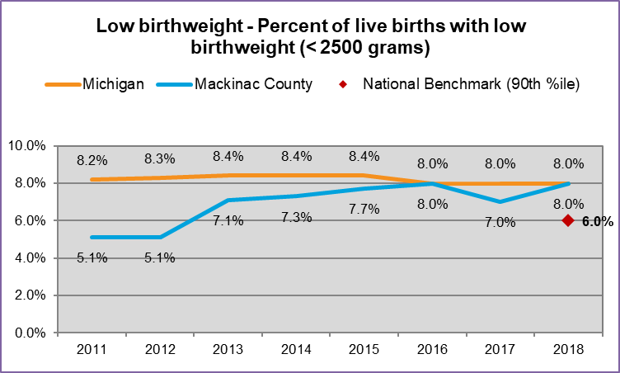

County Health Rankings

Teen birth rates were also analyzed for Mackinac County and compared to Michigan and the Nation. Teen birth rates in Mackinac County have risen in Mackinac County since 2014. Rates are below Michigan but above national benchmarks. The percentage of children in poverty has risen in recent years in Mackinac County however rates dropped to 24% in 2018. Rates are double the national benchmark. This is an important group as poverty among children can often be associated with many negative health consequences throughout childhood.

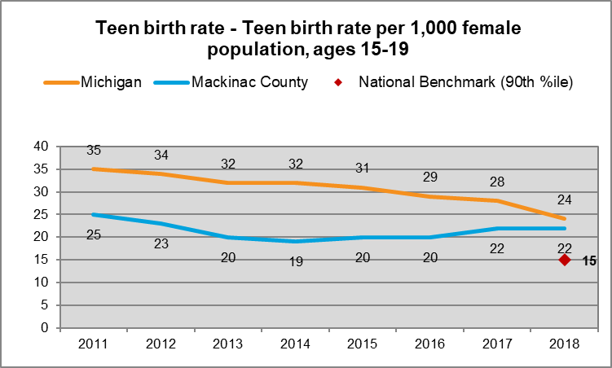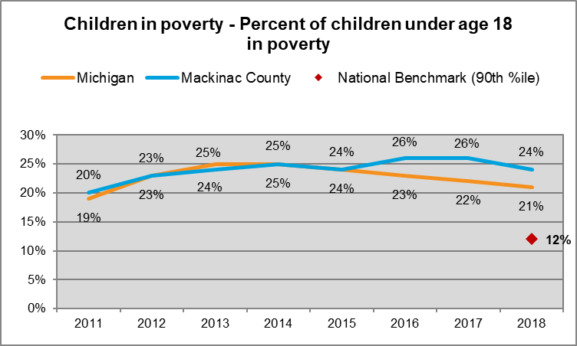

County Health Rankings

## 

## Insurance

Individuals without health insurance often forego care due to high cost, which can lead to a higher prevalence of chronic conditions. The Affordable Care Act has been associated with a downward trend in the rate of uninsured across the Nation. The rate of uninsured adults in Mackinac County has dropped significantly from 2013 from 26% down to 14% in 2018. This rate is still above the national benchmark of 7%.

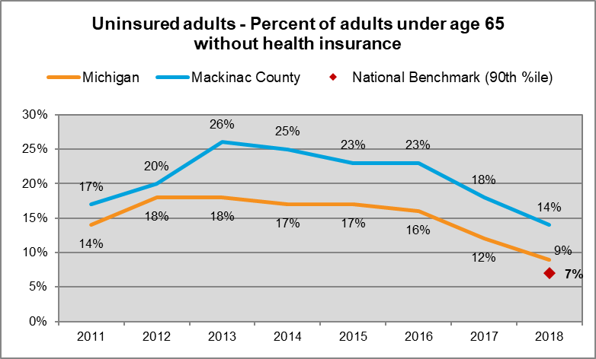

County Health Rankings

**General Population Health**

One measure of health among the community included in the County Health Rankings Nationwide study is reported general well-being. Reported general health of “poor or fair health” in Mackinac County has risen significantly since 2011 to 19%, significantly higher than the national benchmark of 12%. A similar self-reported measure is “poor physical health days,” which refer to days in which an individual does not feel well enough to perform daily physical tasks. Rates in Mackinac County have risen since 2012 to 4.5 days, which is higher than Michigan rate of 4.3 and above the national benchmark of 3 days.

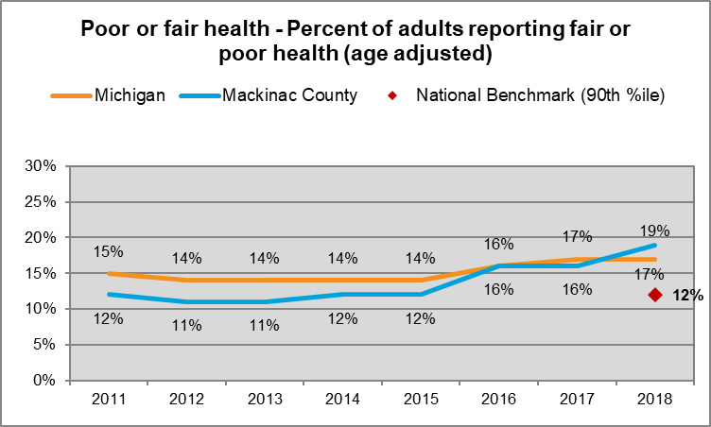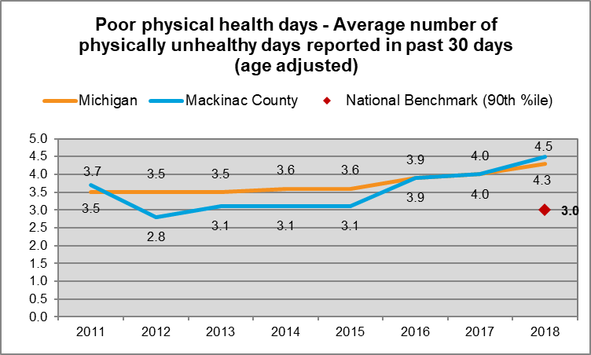

County Health Rankings

A third measure of general health of the population is the percentage of adult obesity. Nationally, the benchmark has been 26% of the population. In Michigan, the percentage of adults who are obese has risen to a peak of 34% in 2014, but declined slightly in 2018 to 30%. The obesity rate is cause for further investigation from a public health perspective.

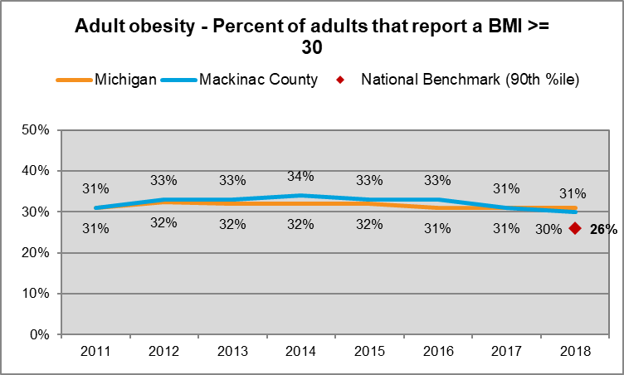

County Health Rankings

Another indicator, “Poor mental health days”, refers to the number of days in the previous 30 days when a person indicates their activities are limited due to mental health difficulties. Mackinac County did not report data for 2014 and 2015, however the last reported rate of 4.5 days in 2018 is higher than Michigan and above the national benchmark of 3.1 days.

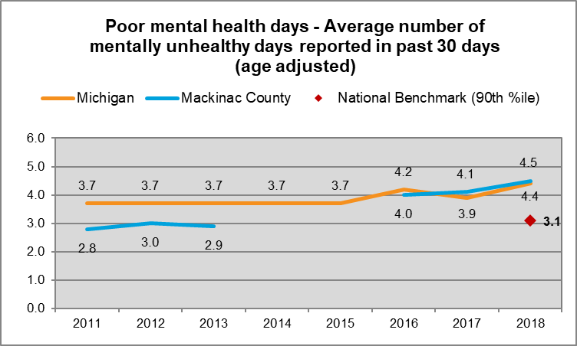

County Health Rankings

## **Screening**

Screening for potential health issues is a major indicator of future health issues within a community. Diabetes, which is one of the major health issues impacting our society today, was analyzed. Diabetes screening rates in Mackinac County have declined to 83% in 2018. This decline places Mackinac County 8% below the national benchmark rate. Coupled with the high obesity rate in Mackinac County, this trend reflects a significant healthcare issue in the County.

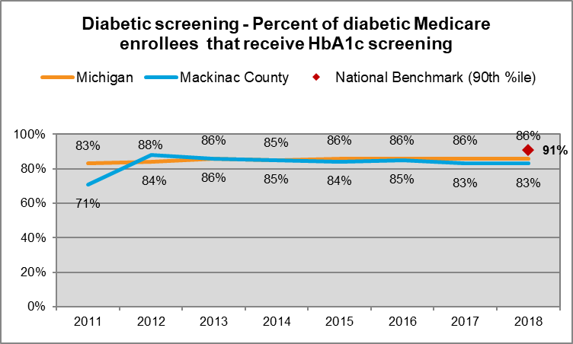

County Health Rankings

Mammography screening has risen in Mackinac County since 2015, from 66% up to 73%. This rise places Mackinac County above the national benchmark rate of 71%

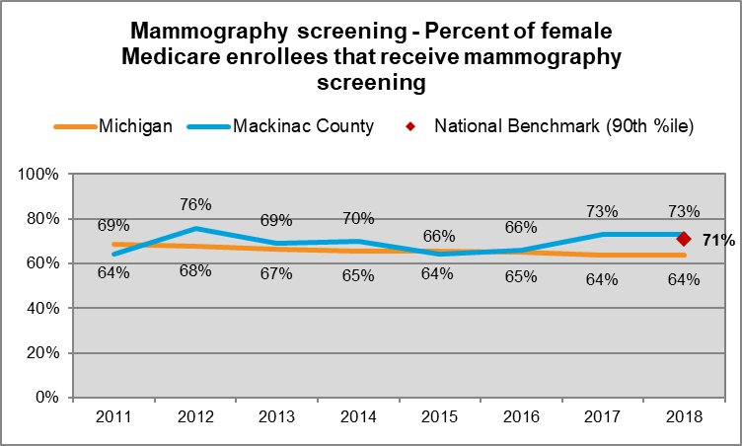

County Health Rankings

## Leading Causes of Hospitalizations

Historical discharge data from 2016 was analyzed to understand the leading causes of hospitalizations per 10,000 population in Mackinac County compared to Michigan. Rates of heart disease hospitalizations are slightly higher than the Michigan rate and have increased since 2013. Injury and poisoning rates are now higher in Mackinac County than Michigan. OB-related rates are expectedly lower for Mackinac County, given the more elderly population and lack of birthing centers, which is similar to the results from 2013. The rate of hospitalization for chronic obstructive pulmonary disease (COPD) and bronchiectasis is twice as high in Mackinac County than in the state of Michigan. Overall, rates of hospitalizations per 10,000 are slightly lower in Mackinac County than Michigan at large.

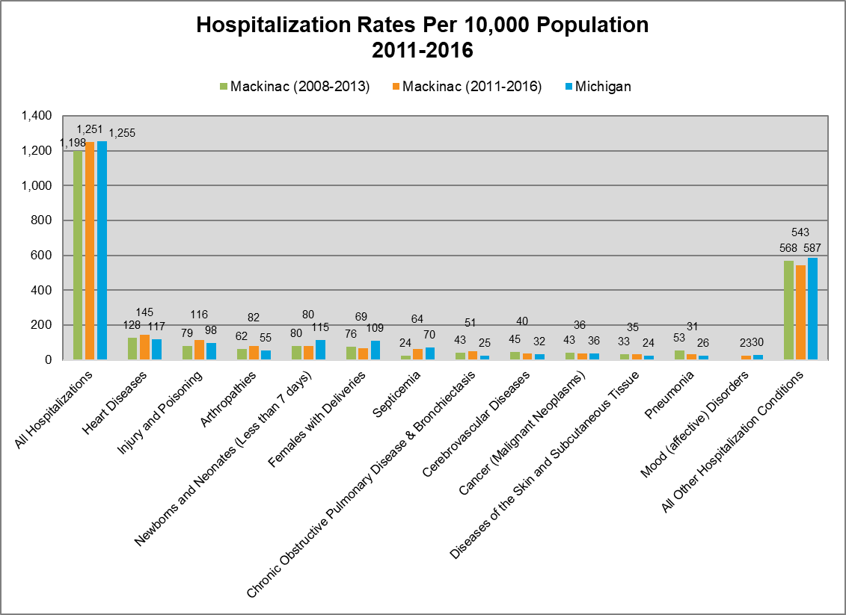

Michigan Department of Public Health, 2019

## Ambulatory Sensitive Conditions

Hospitalization for an ambulatory care sensitive condition (ACSC) is considered to be a measure of access to appropriate primary health care. While not all admissions for ACSCs are avoidable, it is assumed that appropriate ambulatory care could prevent the onset of this type of illness or condition, control an acute episodic illness or condition, or manage a chronic disease or condition. A disproportionately high rate is presumed to reflect problems in obtaining access to appropriate primary care. The rate of ACSC in Mackinac County has declined from 22% in 2011 to 20% in 2016. At the same time, Michigan rates have risen by 1% to 22% over the same period.

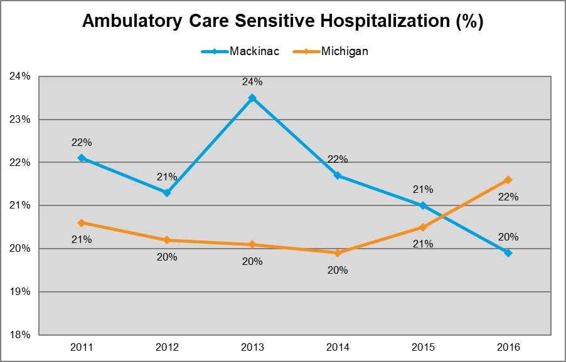

Michigan Department of Public Health, 2019

# Summary of Key Findings and Prioritized Needs

A list of interview participants can be found in Appendix 1. The MSHS Advisory Committee selected individuals with a wide range of backgrounds in health-related agencies and with health-related qualifications to participate in the interviews. These individuals represent the broad interests of the community served by MSHS.

Interview participants were asked a series of questions formed by the Advisory Committee. These questions were developed from a variety of nationally accepted health improvement models and tailored by the committee to uncover the health needs that may exist within the MSHS community. Questions can be found in Appendix 2. Responses were recorded and later condensed into common themes. The following top priorities were identified through the CHNA process:

1. Mental / behavioral health
2. Community education programs
3. Obesity
4. Diabetes

The health needs were prioritized by the CHNA Advisory Committee. The criteria used to prioritize the health needs can be found in Appendix 3. The criteria measures were established by the committee, drawing from recommendations from the National Rural Health Association.

## Existing Health Care and other Facilities and Resources

The following is a list of select health care and other facilities and resources are available within the community to meet the health needs identified through the CHNA. A complete list including location, contact information, and description of services can be found in Appendix 4:

* LMAS District Health Department
* Mackinac County Department of Human Services
* Mackinac Straits Health System & Rural Health Clinic
* Michigan State University (MSU) Extension
* St. Ignace Area Hope Chest Thrift Store and St. Ignace Food Pantry
* Substance Abuse Program – St. Ignace, MI
* Great Lakes Recovery
* United Way of the Eastern Upper Peninsula
* Veterans Trust Fund and Veteran’s Counselor
* West Mackinac Health Clinic
* Dr. Mark Mercer, DDS
* Dr. Scott Clement, DDS
* Mackinac Straits Health System – Long Term Care Facility, Evergreen Living Center
* Castle Rock Retirement Center
* Community Health Access Coalition (CHAC)
* War Memorial Hospital – Cedarville Practice
* Little Bear East Fitness Center
* Pilates Invigorated
* MIchild
* Healthy Kids
* MSHS Charity Care
* Indian Outreach
* Webers and Devers Psychological Services, P.C.
* Great Parents, Great Start
* Early On
* Community Action
* Consolidated Community School Services
* Sault Tribe Health and Human Services
* Hiawatha Behavioral Health

# Implementation Plan

Once the health needs were prioritized by the CHNA Advisory Committee, the final step in the CHNA process involved developing an implementation strategy. The purpose of the implementation strategy is to develop a clear set of goals to respond to the priorities identified through the CHNA. The implementation strategy should include a written plan that addresses each of the community health needs identified through the CHNA, describe how the hospital plans to meet the health needs, and identify health needs the hospital does not intend to meet and why.

The CHNA Advisory Committee developed the implementation strategy. The committee addressed the following implementation strategy components within each priority identified:

1. Objectives/Strategy
2. Tactics (How)
3. Programs/Resources to Commit
4. Impact of Programs/Resources on Health Need
5. Accountable Parties
6. Partnerships/Collaboration

The detailed implementation strategy for each priority can be found in Appendix 5. The implementation strategy detail for each provides supporting tactics, programs/resources, accountable parties, and potential partnerships/collaboration for each strategy.

# **References**

Association for Community Health Improvement

Rural Health Works

Flex Monitoring Team

ESRI Business Information Solutions, 2019

County Health Rankings

Michigan Department of Health

Michigan Vital Statistics

Appendix 1

**List of Interviewees for Community Input**

|  |  |  |
| --- | --- | --- |
| **Name** | **Organization** | **Contact Information** |
| Julie Lipnitz | LMAS District Health Department | 906-643-1100 |
| Cheryl LaPlaunt | St. Ignace Clinic Manager – Sault Tribe | 906-643-8689 |
| Deb Dotts | Community Mental Health – OBRA Coordinator | 906-643-2111 |
| Courtney Grant | Community Mental Health – Children and Outpatient Clinical Manager | 906-643-8616 |
| Terry Allan | Head Start – Sault Tribe | 906-643-9733 |
| Michelle Jarvie | MSU-Extension – Health and Nutrition | 906-643-7307 |
| Frank Harness | Veterans Committee – Mackinac County | 906-484-2385 |
| Lisa Davis | DHS – Mackinac County Office | 906-643-9550 |
| Deana Kreski | LaSalle HS – Student/Family Advocate | 906-643-8500 |
|  |  |  |

Appendix 2

**Healthcare Issues and Accessibility**

1) What do you feel are the most pressing health needs or issues in Mackinac County?

2) What is currently being done to address the issues? If so, how is your organization addressing the issues? If not, in your opinion, why aren't the issues being addressed? If applicable, what ways have these issues been addressed in the past?

3) Rank the size and scope of the most pressing issue(s)/problem(s):

4) How much of a choice do your constituent have when selecting a primary care provider? How does this choice vary based on an individual's insurance coverage? If there is a lack of primary care providers, what do you think that is?

5) How available is insurance for other healthcare services (e.g., dental and prescription services) for your constituents?

6) Are your constituents able to afford out-of-pocket healthcare expenses, such as co-pays or deductibles? If not, why?

**Programs and Services - Existing & New**

7) How well do your existing programs/services meet the needs and demands of your constituents? Why do you feel that way?

8) In your constituents' community(ies), what programs or services are lacking?

9) Are there any program(s)/service(s) your constituents need in the community that do not exist? What? Why?

10) What new programs does your organization plan to implement? What? Why?

11) What barriers face the community that prevent the community from developing a program/service? What solutions would assist the community to break-down the barrier(s)?

Appendix 3

**Criteria Used to Prioritize Health Needs**

|  |  |  |  |  |  |  |
| --- | --- | --- | --- | --- | --- | --- |
| **Theme / Priority** | **Decision Criteria** | | | | | |
| **Severity of Problem?**  **1-5** | **Potential Impact on Health of Population?**  **1-5** | **Feasibility of Change?**  **1-5** | **Resources Available to Address Problem?**  **Y/N (N=5)** | **Alignment with Mission, Strength, Priorities?**  **Y/N (Y=5)** | **Overall Priority Score** |
| Community education programs (e.g., health and services information, for veterans as well as age- or condition-specific populations) | 4 | 4 | 4 | 2 | 4 | 18 |
| Mental/behavioral health services, all ages | 5 | 5 | 3 | 4 | 3 | 20 |
| Transportation (e.g., affordable and reliable) | 4 | 4 | 2 | 5 | 2 | 17 |
| Out-of-pocket costs for health services (e.g., co-pays, private pay, or | 3 | 3 | 2 | 3 | 3 | 14 |
| Obesity | 4 | 4 | 4 | 2 | 4 | 18 |
| Diabetes | 4 | 4 | 4 | 2 | 4 | 18 |
| Low-or-no-cost dental services | 4 | 4 | 2 | 4 | 2 | 16 |
| **SCALE:**  1= Very Low 2 = Low 3= Moderate 4= Moderate High 5= High | | | | | | |

The Decision Criteria was determined by the Advisory Committee consisting of the follow members:

* James Shannon, Chief Nursing & Quality Officer
* Jason Anderson, Senior Accountant
* Marielle St. Onge, Registered Dietician
* Sharon MacDonald, Patient Advocate & Risk Manager

Appendix 4

|  |  |  |  |  |  |  |
| --- | --- | --- | --- | --- | --- | --- |
| **Agency Name** | **Location** | **Contact Person** | **Email** | **Phone** | **Population Served, services provided** | **Hours and Days** |
| LMAS District Health Department | 749 Hombach Street, St. Ignace, MI 49781 |  |  | 906-643-1100 | WIC (Women who are pregnant or breastfeeding, Infants, Children up to age 5 years of age.); Family Planning Program; Immunizations; Children’s special Health Care Services; Breast and Cancer Control Program, Women’s Health (non-family planning); STD Testing; Hearing and Vision Screening  Must meet insurance and income requirement. Some Programs are free while others may be based on income and will have a nominal fee. | Monday – Thursday  8:00am to 4:00 pm |
| Mackinac County Department of Health and Human Services  (DHHS) | 199 Ferry Lane, St. Ignace, MI 49781 | Linda DeKeyser |  | 906-643-9550  1-855-444-3911  Centralized Intake number for child abuse and neglect | Food Assistance, Cash Assistance, Child Care, Medical Assistance, Emergency Relief, Foster Care, Adoption,  Transportation for medical appointments if individual meets criteria. | 8:00 am to 5:00 pm Monday-Friday  Closed for State Holidays |
| MIchild | Mackinac County Department of Health and Human Services  199 Ferry Lane  St. Ignace, MI 49781 |  | www.michigan.gov/mdhhs | 906-643-9550 | A health care program for the uninsured children of Michigan’s working families. It is income based but accepts a higher income than Healthy Kids. It is for children under 19. There is a $10 monthly premium. | 8:00 am to 5:00 pm Monday-Friday |
| Healthy Kids | Mackinac County Department of Health and Human Services  199 Ferry Lane  St. Ignace, MI 49781 |  | www.michigan.gov/mdhhs | 906-643-9550 | A Medicaid health care program for low income children under 19 and pregnant women of any age. It is income based and no monthly premium. It includes dental, vision and mental health services. | 8:00 am to 5:00 pm Monday-Friday |
| **Agency Name** | **Location** | **Contact Person** | **Email** | **Phone** | **Population Served, services provided** | **Hours and Days** |
| Mackinac Straits Health System  St. Ignace Medical Clinic | 1140 North State Street, St. Ignace, MI 49781 | Laura Matson | [lmatson@mshosp.org](mailto:lmatson@mshosp.org) | 906-643-0466 | Family Practice, Women’s Health, Geriatric Medicine, Pediatrics, Internal Medicine, Cardiology  **Additional Visiting Specialists** | 8:00am to 5:00pm |
| Michigan State University (MSU) Extension | 749 Hombach Street, St. Ignace, MI 49781 | Jim Nash  Susan Kirkham  Michelle Jarvie  Tracie Abrams |  | 906-643-7307 | Michigan State University Extension provides high quality and affordable education to the community. Topics include caregiving, bullying, aging, chronic disease, budgeting, food preservation, nutrition, physical activity, safe food and water, weight management, early childhood development, managing relationships, finance, and violence prevention.  **Fee varies depending on session**. | Monday-Friday  10:00 am to 2:00 pm |
| St. Ignace Area Hope Chest Thrift Store and St. Ignace Food Pantry | P.O Box 170/250 Ferry Lane, St. Ignace, MI 49781 | Craig Lehrke |  | 906-643-6780 Assistant Hotline  906-643-7360 Hope Chest and Food Pantry | Provides food to those in need.  Clothing and household items available to purchase for nominal charge. | Hope Chest TWTH 10:00 am to -4:00 pm  Food Pantry TWTH 2pm-4pm but can also call the HOTLINE if necessary |
| Substance Abuse Program; Great Lakes Recovery | 799 Homach Street Suite 2, St. Ignace, MI 49781 | Mark Boshaw |  | (906) 643-9809 | Substance Abuse Counseling only  Cost will be determined at screening via the telephone.  Individuals with Commercial Insurance will be scheduled to be seen in the Sault Ste Marie, MI location and not at Mackinac County location. BCBS patients can be seen in St. Ignace | Monday – Friday 9:00am to 5:00pm  Appointment necessary |

|  |  |  |  |  |  |  |
| --- | --- | --- | --- | --- | --- | --- |
| **Agency Name** | **Location** | **Contact Person** | **Email** | **Phone** | **Population Served, services provided** | **Hours and Days** |
| United Way of the Eastern Upper Peninsula | 511 Ashmun St. Suite 103  Sault Ste. Marie, MI 49783 | Ravianiesa Aranda | volunteer@unitedwayeup.org    Facebook page: UnitedWayEUP | 906-632-3700 extension 3 | A point of service for all human resources providers, assistance with utilities, housing, transportation, health, medical, food needs, etc. Also provides free tac preparation online DHHS services, a kiosk for online application. Services Chippewa, Luce and Mackinac Counties. | Monday –Friday 9:00am to 5:00 pm |
| Veterans Trust Fund and Veteran’s Counselor | 100 Marley, Room 105  St. Ignace, MI 49781 | Richard Litzner | [mackcovet@lighthouse..net](mailto:mackcovet@lighthouse..net) | 906-643-9411 | Coordination of services for Veterans.  VFW consultant for filing claims | Wednesday 9:00am – 3:00 pm  Tuesday & Thursday 9am – 4pm |
| Hiawatha Behavioral Health | 114 W Elliot St.  St. Ignace, MI 49781 |  |  | 906-643-8616  24 hour crisis line 800-839-9443  TTY 906-632-5539 | Mental health facility. Serves all ages. Programs for youth with serious emotional disturbance, mental illness, mental health and substance abuse disorder, Post-Traumatic Stress Disorders  Crisis Intervention Team  Psychiatric Emergency Walk-in Services | Monday – Friday 8am – 5pm |
| Love in the Name of Christ | W 14015 Melville  Engadine, MI  49827 | DeWayne Evans |  | 906-477-1050 | Medical equipment loaned if returned.  Serves west end of Mackinac County residents only.  Provides food and clothing available free or nominal charge. | Thrift Store:  Tuesday – Friday 10am – 4pm  Saturday – 10am – 1pm  Food Pantry:  Tuesday – Thursday –10am – 3pm |
| West Mackinac Health Clinic | W 14034 Melville Street  Engadine, MI 49827 | April Masters |  | 906-477-6066 | Serves west end Mackinac County. Provides all health services as an outreach clinic with Helen Newberry Joy Hospital | Tuesday and Wednesday  10pm-4pm  Friday 9am – 12p  Closed for lunch noon - 1pm |
| Dr. Mark Mercer, DDS | W492 Portage  St. Ignace, MI 49781 | Office Staff | staff@markmercerdds.com | 906-643-8414 | Does not see Medicaid patients | Mon-Thurs  8:30am to 4:30pm |
| **Agency Name** | **Location** | **Contact Person** | **Email** | **Phone** | **Population Served, services provided** | **Hours and Days** |
| Dr. Scott Clement, DDS | 314 N. State  St. Ignace, MI 49781 | Office Staff | info@scottclementdds.com | 906-643-9245 | MI child with Delta Dental  Does not see Medicaid patients | Hours MWR 8am – 5pm  Tues 8am -2:30pm |
| Mackinac Straits Health System, Long Term Care Facility; Evergreen Living Center | 1140 North State Street, St. Ignace, MI 49781 | Kevin McElroy |  |  | Forty eight bed skilled nursing facility. Services provided for long term care as well as short term rehab car. Accommodates residents requiring Hospice Care, nursing care, restorative care, activities and social services. |  |
| Castle Rock Retirement Center | 255 S. Airport St. Ignace, MI 49781 | Laura Willey |  | 906-984-2323 | 38 Beds, NOT SKILLED nursing, all care, meals, activity aids, end of life care.  Private pay starting at $1,995/month with Ala Carte services available. Extra costs depending on care level. Not furnished.  VA benefits for those who qualify |  |
| Community Health Access Coalition (CHAC) | Chippewa County  Mackinac County  Luce County |  |  | 643-7483 | The Community Health Access Coalition (CHAC) is a non-profit, volunteer organization coordinating access to health care for uninsured residents of Chippewa, Luce, and Mackinac Counties in the Eastern Upper Peninsula of Michigan (EUP). CHAC coordinates discounts at area hospitals and with primary care providers.  We also assist with paperwork to receive free and discounted medications through pharmaceutical companies. Help individuals with Marketplace Plan and Medicare. | Hours vary by office location |
| **Agency Name** | **Location** | **Contact Person** | **Email** | **Phone** | **Population Served, services provided** | **Hours and Days** |
| ZUMBA | 326 Paro St  St. Ignace, MI  49781 | Rosemary Brown | rosemarybrown.zumba.com | 906-430-1025 | Cardio and Toning Fitness  Classes are free | Monday - Thursday at 5:30pm  Hours subject to change |
| State Farm Insurance | 8 North State St., St. Ignace, MI 49781 | Mark Elmblad |  | 906-643-9866 | BCBS | M - F 9 am - 4:30 pm |
| Cheeseman Insurance Agency | 470 N. State St  St. Ignace, MI  49781 | Gregory S. Cheeseman | [solutions@cheesemanagency.com](mailto:solutions@cheesemanagency.com) | 906-643-6500 | Health Insurance BCBS Only | Monday-Friday  8:00am—4:30pm |
| **Agency Name** | **Location** | **Contact Person** | **Email** | **Phone** | **Population Served, services provided** | **Hours and Days** |
| Little Bear East | 275 Marquette Street, St. Ignace, MI  49781 | Scott Marshall |  | (906)643-6081 | Fitness Center with fully equipped weight room. Aerobics class offered September through June.  Skating and indoor with walking (call for times) | M-F 5am to 8pm and  Sat –Sun 8am to 8pm  M – Th 8pm – 9pm Women only  Costs:  Fitness Center $5 daily/$20 weekly  Resident* Monthly $35  Non-Resident Monthly $40  Resident* 6 months $175  Non-Resident 6 months $200  Resident* 1 year $315  Non-Resident $360  *Resident: Reside in City of St. Ignace or St. Ignace Township.  Moran Township residents free with township voter registration validation  Sault Tribe members free with tribal card validation  All Business/Group discounts membership must be paid directly at the Little Bear East Office  Aerobics: M, W and Thursday 5:15pm to 6:30pm  Aerobic Classes Daily $3  Aerobic Classes Monthly $20 |
| War Memorial Hospital – Cedarville Practice | 391 E M-134, Cedarville, MI 49719 | Office Staff |  | 906-484-2295 | Family Practice  Laboratory and Radiology Service | Monday - Thursday 8:00 am 5:00 pm |
| MSHS Charity Care | 1140 North State Street, St. Ignace, MI 49781 | Stacey Oja | soja@mshosp.org | 906- 643-1186 |  | Mackinac Straits Health System partner with patients to meet their needs by offering affordable medical care to those with limited resources.  Cost for medical services will be based on financial need. |
| **Agency Name** | **Location** | **Contact Person** | **Email** | **Phone** | **Population Served, services provided** | **Hours and Days** |
| Mackinac Straits Health System | 1140 North State Street  St. Ignace, MI 49781 |  | [www.mshosp.org](http://www.mshosp.org) | 906-643-8585 | 24 hour Emergency Room  Bone Density Testing  Cardiac Rehabilitation  Cardiac Testing  Diabetic Education  Employee Wellness Program  Inpatient Care  Laboratory Services  Radiology Services; including ultrasound, mammography and MRI  Oncology  Outpatient Surgery  Physical, Speech Occupational and Aqua Therapy |  |
| Indian Outreach | 199 Ferry Lane, St. Ignace, MI 49781 | Ronda Engle | [engler@michigan.gov](mailto:engler@michigan.gov) | 906-643-6115 | Works with individuals and families to overcome barriers by connecting services with the needs of the family. They provide prevention services and works as an advocate to families by being a liaison between agencies to give the families the support they need to become self-sufficient. | M-F 8am – 4pm |
| **Agency Name** | **Location** | **Contact Person** | **Email** | **Phone** | **Population Served, services provided** | **Hours and Days** |
| Webers and Devers Psychological Services, P.C | 605 E 7th St  Suite 9  SSM, MI 49783 | Jeannie Neal | office@weberanddevers.com | 906-635-7270 | Serves all ages and offers all psychological services including therapeutic, assessment, and consulting, and substance abuse services.  Cost varies by service. Accepts Upper Peninsula Health Plans as well as private insurance. | M – F 8am – 5pm  Possible evenings by appointment |
| Diane Peppler Resource Center | 246 Ferry Lane  St. Ignace, MI  49781 | Mallory Schley |  | 906-643-0498  800-882-1515 | Diane Peppler Center was established to offer fellowship, beds, warmth, transportation, food, clothing and time to think in a secure atmosphere. A 24-hour hot line, crisis support counseling is available as well as an emergency medical service, legal and financial referrals and advocacy for victims of family violence and their children. Victims of Domestic Violence are eligible | Call for appointment |
| Great Parents Great Start | EUPISD  315 Armory Place  SSM, MI 49783 | Cara LaFaver | clafaver@eupschools.org | 906-632-3373 Extension 5123 | A home based educational program for children birth to five years old if not in any other early childhood program.. This program emphasizes the importance for parents as teachers for their child.  No cost.  In home services | Call for appointment |
| Early On | EUPISD  315 Armory Place  SSM, MI 49783 |  |  | 906-632-3373  Extension 5142 | 0-3 years of age  20% Developmental delay or established medical condition to qualify for services.  Free of charge  Home visits to do an assessment provide OT, PT, ST  Number of home visits dependent on need and plan for child  Referral from anyone | Call for appointment |
| **Agency Name** | **Location** | **Contact Person** | **Email** | **Phone** | **Population Served, services provided** | **Hours and Days** |
| Tribal Health Facility | 1140 North State Street  St. Ignace, MI  49781 |  |  | 906-643-8689 | Many services including:   * Medical * Dental * Optical * Pharmacy * Nursing Services * Traditional Medicine * Behavioral Health Services * Community Health Services * ACAF (Anishnaabek Community and Family Services) | Monday - Friday  8 am – 5 pm |
| Cedar Post Thrift Shop | 362 E. M-134  Cedarville, MI  49719 | George Boulgaris |  | 906-484-9512 | Food Pantry, clothes, dishes by donations | Monday -Saturday  12-4 pm |
| **Agency Name** | **Location** | **Contact Person** | **Email** | **Phone** | **Population Served, services provided** | **Hours and Days** |
| Community Action | 368 Regan Street  St. Ignace, MI  49781 | Don Wright | [dwright@clmcaa.com](mailto:dwright@clmcaa.com) | 906-643-8595 | Home Injury Control, [Homemaker Services](http://www.clmcaa.com/homemaker.html), [Loan Closet](http://www.clmcaa.com/seniors/Loan%20Closet.pdf), [Meals on Wheels](http://www.clmcaa.com/mealsonwheels.html), [Nutrition Program](http://www.clmcaa.com/mealsonwheels.html), [Personal Care](http://www.clmcaa.com/homemaker.html), [Private Duty Services](http://www.clmcaa.com/homemaker.html), [Respite Care](http://www.clmcaa.com/homemaker.html), [Service Coordination](http://www.clmcaa.com/homemaker.html), [Take Five Adult Day Care](http://www.clmcaa.com/take5.html), Senior Events, MMAP (Michigan Medicare/Medicaid Assistance Program), [Creating Confident Caregiver Training](http://www.clmcaa.com/CCC.pdf), Home Buyer Education, Home Buyer Purchase Rehabilitation, Neighborhood Preservation, Property Management / Rentals, [CDBG Home Rehabilitation Program](http://www.clmcaa.com/cdbg.html), Home Weatherization Program, Early Head Start, Head Start, [Community Development Block Grant (CDBG)](http://www.clmcaa.com/cdbg.html), Commodity Surplus Food Program, [Targeted Emergency Food Assistance Program (TEFAP)](http://www.clmcaa.com/tfap.html), [Emergency Services](http://www.clmcaa.com/emergencyserv.html), Free Tax Preparation Assistance, Outreach Services |  |
| Consolidated Community School Services | CCSS - Les Cheneaux Area  P.O. Box 366  Cedarville, MI 49719 | Kate Ter Haar | kterharr@eup.k12.mi.us | (906)  484-2256  extension 5 | Adult and community education classes(GED classes, alternative high school, and preschool) | Times vary for classes |

Appendix 5

Mackinac Straits Health System

St. Ignace, Michigan

Community Health Needs Assessment

Implementation Plan

**Note: Issues pertaining to transportation, out-of-pocket costs for health services, and low-or-no-cost dental services were not prioritized as the Top 4 community health needs. These issues were excluded from individual implementation for business purposes, but their themes were incorporated into the implementation plan(s) of other community health needs.**

**Priority: Mental Health / Behavioral Health Services**

Objective/Strategy

|  |
| --- |
| * To collaborate with Mackinac County mental / behavioral health resources to improve community and patient awareness of mental / behavioral health services in our community. |

Tactics (How)

|  |
| --- |
| * Facilitate Community Task Force at Mackinac Straits Hospital * Coordinate with resources in the state available to assist clinic patients * Coordinate with local or regional resources to promote discussion of community needs and possible solutions * Promote Mental Health / Behavioral Health Awareness during one month a year |

Programs/Resources to Commit

|  |
| --- |
| * Community Task Force * MSHS Social Worker * MSHS Clinics Leaders |

Impact of Programs/Resources on Health Need

|  |
| --- |
| * Improved utilization of mental health / behavioral health service among community members |

Accountable Parties

|  |
| --- |
| * MSHS Leadership * Community partners, patients and families |

Partnerships/Collaboration

|  |
| --- |
| * Hiawatha Behavioral Health * Business leaders * Sault Tribe of Chippewa Indians * Hope Network – Bay Haven Crisis & Integration Care * Non-governmental organizations in the state |

**Priority: Community Education Programs**

Objective/Strategy

|  |
| --- |
| * Collaborate with community and state organizations to improve awareness of available health and nutrition education programs and services in Mackinac County. |

Tactics (How)

|  |
| --- |
| * Connect with community resources to identify scope of services available * Coordinate with MSHS’ Clinic Leaders to share information about community education resources * Schedule meetings at MSHS, and provide the space and assistance to help organizations promote their services to MSHS and Mackinac County. |

Programs/Resources to Commit

|  |
| --- |
| * MSHS Leadership * MSHS Social Worker * MSHS Clinics’ Care Manager * MSHS Patient Advocate |

Impact of Programs/Resources on Health Need

|  |
| --- |
| * Improved awareness and utilization of programs available in Mackinac County |

Accountable Parties

|  |
| --- |
| * MSHS Leadership |

Partnerships/Collaboration

|  |
| --- |
| * MSU-Extension * Sault Tribe of Chippewa Indians * Mackinac County Veterans * LMAS Health Department |

**Priority: Obesity**

Objective/Strategy

|  |
| --- |
| * Improve community participation in MSHS obesity programs and make the Mackinac County community more educated about weight management and the health risks of obesity |

Tactics (How)

|  |
| --- |
| * Secure a care manager for MSHS’ Clinics * Connect MSHS patients with local resources for managing obesity * Presentation table for one month a year to educate the community on obesity |

Programs/Resources to Commit

|  |
| --- |
| * MSHS Leadership * MSHS Registered Dietician * MSHS Clinics’ Care Manager |

Impact of Programs/Resources on Health Need

|  |
| --- |
| * Decrease in the county obesity rate * Improved screening for obesity |

Accountable Parties

|  |
| --- |
| * MSHS Leadership * MSHS Dietician |

Partnerships/Collaboration

|  |
| --- |
| * MSU-Extension * LMAS Health Department * Sault Tribe of Chippewa Indians |

**Priority: Diabetes**

Objective/Strategy

|  |
| --- |
| * Improve community participation in MSHS diabetes programs and make the Mackinac County community more educated about blood glucose management and the health risks of diabetes. |

Tactics (How)

|  |
| --- |
| * Secure a care manager for MSHS’ Clinics * Connect MSHS patients with local resources for managing diabetes, including on-site diabetes educators (e.g., Sault Tribe Clinic) * Continue assessing the potential for developing a Diabetes Education Program * Continue meeting monthly for the Diabetes Support Group and incorporate local or regional resources for guest speakers |

Programs/Resources to Commit

|  |
| --- |
| * MSHS Social Worker * MSHS Registered Dietician * MSHS Clinics’ Care Manager |

Impact of Programs/Resources on Health Need

|  |
| --- |
| * Improved screening for diabetes * Improved A1C levels for MSHS’ patients |

Accountable Parties

|  |
| --- |
| * MSHS Leadership * MSHS Clinics’ Care Manager |

Partnerships/Collaboration

|  |
| --- |
| * MSU-Extension * LMAS Health Department * Sault Tribe of Chippewa Indians |